Assignment 2
240165
Anuska Keshri
1. A perceptron implements a linear classifier of the form
$$y=\text{sign}(w^{T}x+b)$$
Hence, it can only separate data that is linearly separable. The XOR problem is not linearly separable, so no single hyperplane can classify it correctly. Therefore, a single perceptron cannot solve XOR.
When multi-layer perceptrons were introduced, hidden layers with non-linear activation functions allowed the network to learn intermediate representations. This enables the model to form non-linear decision boundaries, making XOR solvable.
2. If multiple linear layers are composed:
$$y=W_{2}(W_{1}x)=(W_{2}W_{1})x$$
The result is still a linear transformation. Hence, stacking linear layers without non-linear activations does not increase model expressiveness.
During backpropagation, gradients are computed as a product of derivatives across layers. If these derivatives are small (as in sigmoid or tanh activations), repeated multiplication causes gradients to approach zero, leading to the vanishing gradient problem. This makes learning in early layers slow or impossible.
Sigmoid saturates for large positive or negative inputs, resulting in near-zero gradients. ReLU has a constant gradient of 1 for positive inputs, preventing gradient shrinkage and allowing better gradient flow in deep networks.
3. Transformers use self-attention, which is permutation invariant and does not capture word order. Positional encoding is required to inject sequence order information into token embeddings.
Difference between sinusoidal PE and absolute PE
Sinusoidal positional encoding uses fixed trigonometric functions and can generalize to longer sequences. Absolute positional encoding uses learned embeddings and is limited to the maximum training sequence length.
Why RoPE helps with long contexts
Rotary Positional Embeddings encode positional information as rotations in embedding space. Attention scores depend on relative positions, allowing better generalization to longer contexts compared to absolute positional encodings.
4. Query (Q): represents what the token is searching for
Key (K): represents what each token offers
Value (V): contains the actual information to be aggregated
As dimensionality increases, dot products grow in magnitude, causing softmax to saturate. Scaling by sqrt{d_k} stabilizes gradients.
In self-attention, each token is most similar to itself, making Qi.Ki largest. Hence, diagonal elements dominate.
5. Multi-head attention allows the model to attend to information from different representation subspaces simultaneously, capturing diverse relationships such as syntax and semantics.
Meaning of parameters
- d_model: embedding dimension
- h : number of attention heads
- d_head: dimension of each head
6. Greedy decoding selects the most probable token at each step, which may lead to locally optimal but globally suboptimal sequences.
Beam search maintains multiple candidate sequences at each step, allowing exploration of future possibilities and improving overall sequence probability.
A greedy choice may select a high-probability early token that leads to a low-probability sequence, while beam search finds a sequence with higher total probability.

SOLVING and CODING
1. 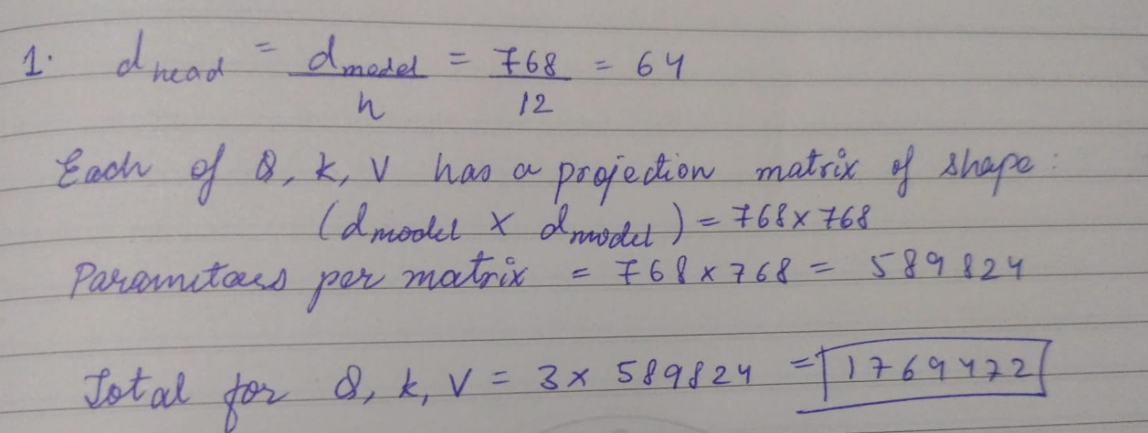
2. 